Loftus Lifelines 4/19
Lorie traveled to Arizona in January and again in March to visit her parents and to follow up on many prayers asking for wisdom for their future care. Though it is difficult to leave their AZ home and friends, Lorie’s parents will be relocating to WI in late April to be closer to family. Both Dean and Lorie, along with other family members and friends, will help facilitate during the transition.
After much thought and prayer, Isaac made the decision to work on Camp Ironwood’s staff this summer. He will be serving as a “grounds foreman” with leadership campers. While he will be missed at home, clearly this is God’s plan and another step in his maturity in Christ.
Gannett, needing greater finances for school and yet wanting to have a ministry outreach in his field, believes that God has led him to work a job this summer. However, he plans to travel on a medical mission team as well. The team will serve in Benin, West Africa for a few weeks in August. Lord-willing, he will experience the best of both worlds – being at home and returning to beloved Africa.
Along with traveling for camp and serving at winter camps, Dean and Lorie have been making preparations for summer ministry as well. For the Lodge building project, God has provided work groups, a backhoe, and some funding. For the summer staff, God is bringing to the team those whom He chooses: counselors, cooks, program team members, operations staff, etc. Both Dean and Lorie rejoice at the work of God’s Spirit in their own lives and the lives of others at the 2019 winter camps!
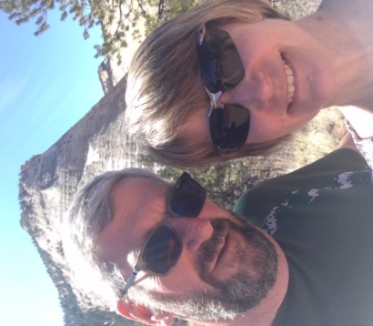
At the start of the new year Lorie fell while ice skating, fracturing her right thumb and injuring her fingers and wrist as well. Thankfully, she is left-handed, but after three months the injury has not healed. With a busy traveling and speaking schedule this Spring, not to mention summer camp on the horizon, Lorie would love to see significant healing in the next couple of months.
During Men’s Retreat, Dean slipped going down to the Pavilion and landed on his right arm. The upper arm bone is bruised and the shoulder is still tender. This is a case of “time heals all wounds.” If Dean and Lorie stand together, which they plan to do , with two left hands they can accomplish a lot!
Green grass is poking up through vestiges of snow and dead, brown grass! While we truly love winter, the thought of warmer temperatures and a dry camp road encourages our hearts! Knowing God is in control, is hearing our prayers, and is working His divine plan for His glory certainly are reasons to rejoice!

Praises
• Grace in trials
• Answered prayers for care of parents

Prayer Requests
• Provision for dental care
• Provision for Gannett’s and Isaac’s summer ministries

Because of Grace,
Dean and Lorie Loftus

