MacGill’s Meanderings… April 2019
Dear Partners in Prayer,
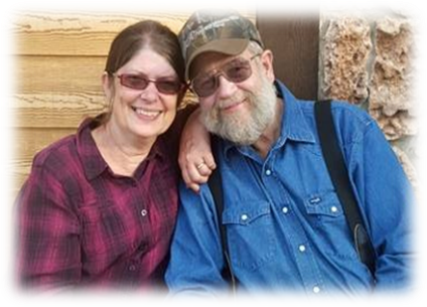
The winter weather started out slowly and mildly, but February and March both made up for “lost time.” April’s weather in this part of Wyoming is very unpredictable. We are thankful for the snowpack, but would ask you to pray with us that the Red Cliff team would be able to get in to camp in good time to get a start on the next part of the Lodge construction. God knows the need!
January was busy with preparations for the Winter Retreats. In February we were able to be at the first two of the retreats (Couples’ and Youth), serving where needed and operating the Higher Grounds Coffee Shop. What a joy it was to see lives being impacted with God’s Word during those retreats. God had other plans for us during the last two retreats.
In February, tests revealed that Dick has a return of cancer, this time in the bone. Treatment is underway. Dick had follow-up exams to diagnose the precise location of the cancer, after which he had a cryotherapy procedure in Salt Lake City in March. After healing from that, he began two weeks of radiation therapy in Idaho Falls, ID. Doctors are optimistic that we can keep ahead of the cancer with careful watching. We are so thankful for the kindness and hospitability of friends in each location allowing us to stay in their homes during those times of travel and treatment! Please pray with us, that our Great Physician would make the treatments completely effective.
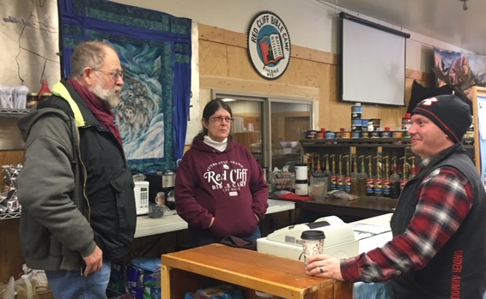
We are looking forward to preparing two Chuck Wagon meals for churches in Idaho during the month of June. This is in addition to the work that we will be doing up at Red Cliff Bible Camp property. Join us in asking the Lord to bless those occasions with safety and to work in hearts of those who will attend.

Serving that others might minister,
Dick & Deirdre MacGill

